Accessing Form and its Elements

In this tutorial, we will learn how to access different elements of a form using Selenium WebDriver. A form consists of various elements like text box, email field, password field, text area, radio buttons, checkbox, dropdowns, links, etc.

Let us learn how to interact with all these web elements and actions which can be performed

* Input  Box – It consists of either a text field or an email field or a password field. The action which we can perform in a text box are:
* Passing Text – method used is sendKeys(“String”);
* Clearing Text – method used is clear();

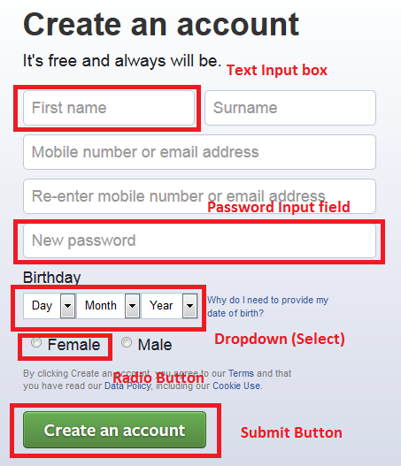

* Radio Button – Radio button allows you to select one option out of many. The Action which can be performed on a radio button is click().

//To select a radio button - click() method is used

driver.find_Element_by_id("u_0_f").click()

* Checkbox – Checkbox allows multiple selections as well. A checkbox can be toggled ON/OFF by click() method.

//To toogle a checkbox - click method is used

driver.find_Element_by_xpath("//input[@type='checkbox']").click()

Working with Dropdown in Selenium WebDriver

we will learn how to work with Dropdowns using Selenium WebDriver. We all must have come across Dropdowns while filling up forms where you select one option out of several options. Sometimes, you get a dropdown where you can select multiple options too. we will learn how to handle those dropdowns using Selenium WebDriver as well. Selenium provides us with a **“Select”**  class to perform operations on dropdown. This class can be found under the Selenium’s Support.UI.Select package.

## ****Select class from Selenium WebDriver is used to handle Dropdown.****

Now this **dropdown** object of class Select has below methods to work with on a Dropdown:

* **selectByValue(“value”);** – Selects an option by value from a dropdown.
* **selectByVisibleText(“text”);** – Selects an option by visible text from a dropdown.
* **selectByIndex(index);** – Selects by index from the dropdown.
* **deselectByValue(“value”);** – Deselects an option by value from a dropdown.
* **deselectByVisibleText(“text”);** – Deselects an option by visible text from a dropdown.
* **deselectByIndex(index);** – Deselects an option by index from a dropdown.
* **deselectAll();** – Deselects All options in a dropdown.
* **isMultiple();** – Boolean operation which verifies whether a dropdown allows multiple selection or not.
* **getOptions();** – Returns a list of all options from a dropdown.
* **getFirstSelectedOption();** – Returns first option selected in a dropdown as a WebElement .
* **getAllSelectedOptions();** – Returns a list of all selected options in a dropdown.

*Sample Code*

**from** **selenium.webdriver.support.ui** **import** Select

select = Select(driver.find_element_by_name('name'))

select.select_by_index(index)

select.select_by_visible_text("text")

select.select_by_value(value)

List box

## What are Lists?

Lists are a collection of similar type data and make things  presentable and easy to read on a Web Page. There are two types of lists in HTML:

Ordered List – represented by <ol>..</ol> tag. Each list item starts with the **<li>** tag

<ol>

<li>Coffee</li>

<li>Tea</li>

<li>Milk</li>

</ol>

Unordered List – represented by <ul>..</ul> tag. Each list item starts with the **<li>** tag.

<ul>

<li>Coffee</li>

<li>Tea</li>

<li>Milk</li>

</ul>

allProduct = driver.findElements_by_xpath("//ul[@id='____']/li"))

for product in allProduct:

System.out.println(product.getText());